Nov 5th FREE LAUNCH NIGHT: Triples, Tears and Tango - New Modern Jive night with a twist
We are pleased to announce that we are launching a regular weekly Thursday night class and freestyle night at Ralli Hall. It offers beginners a great introduction to Modern Jive, whilst for the more experienced dancer the Triples, Tears and Tango class will teach technique/style/moves inspired from other dances such as (westcoastswing/blues/tango). Whilst this is going on beginners can either join in or repeat/practice the first class. Between the classes and at the end of the evening we will play great music to dance to up till 11pm. All in all a great Thursday night out in a lovely venue. Launch night is totally free!!!
Oct 31st Halloween Thriller + Ballroom/WCS BootCamps - MASSIVE WEEKEND
decaDance sure will be a roadblock. 2 rooms, finest sprung wooden floors, 2am finish, great dancers, fab music (upstairs -Jive, WCS, Blues, RnB, Latin + downstairs Tango), Thriller Stroll with Mad Lizzie, Saxxy Miss T on Sax in main room, clarinet in milonga. Tickets £10 door or only £8 advance but you need to prebook before end Friday 30th Oct via email or facebook (http://www.facebook.com/event.php?eid=135643008710 ).
Plus learn the fundamentals of social foxtrot, waltz, quickstep, chacha, rhumba, jive with 3 times, World Professional Ballroom Champion, Hazel Newberry MBE. Booking forms + videos at www.ballroombootcamp.co.uk. Also 2009 UK WCS Open Champion is back with extended beginners bootcamp – learn the basic patterns, + musicality/style tips. Great value – just £15 for two hours beginners intensive plus entry to decaDance to practice. You can also do the Improvers for no extra. Total Beginners (16.30-18.30) and Improvers (19.00-21.00). To book email us or add yourself to http://www.facebook.com/event.php?eid=135643008710
decaDance 'Hot August Nights' arriving in Hove on 8th + 29th August
Following our Waltham Abbey road trip and Tea Dance in July, August sees the Full Fat decaDance return to Ralli Hall in Hove on a Saturday night. Two hot dates for you full of the best music in two rooms, finest dancers coming from miles around plus as ever that late night finish. Also returning are the Saturday pre-decaDance WestCoastSwing classes with 2009 UK WCS Open Champ fantastic American Rachel Martino. If you have been thinking about giving WestCoast a go, this is your perfect opportunity because Rachel will be with us on both dates with lessons for improvers and extended time for beginners.
First decaDance Cream Tea Dance is Sunday 12th July
Following the success of our tango tea dances we will run our first decaDance Cream Tea Dance. All the fun stuff from decaDance plus all the Full Fat calories you would expect from a proper English Cream Tea (homemade scones, clotted cream, posh sandwiches -egg/cress/smoked salmon!). From 17.00 until 19.30 we will be rinsing out the finest Full Phat tunes. Main room will be very much in a funky wcs direction whilst the second room will have mainly tango wth a smattering of slow blues. Plus when this luscious indulgence ends we will all go down to the Funky Fish in Brighton where entry will be FREE to all who attended decaDance. Please email info@tangobootcamp.co.uk or add yourself in to facebook event http://www.facebook.com/event.php?eid=113289976718.
decaDance 4th July North and South American Party
A 4th July party with a difference. This is our first decaDance outside of Hove and is part of our 2 day tangobootcamp at Waltham Abbey Town Hall. So we will run one room dedicated to South America (tango) and one dedicated to North America (jive, swing, westcoastswing, blues). Lots of great themed foody snacks available and if the weather is fine the promise of a little alfresco dancing - 'Viva la revolution' Will be a great night with loads of new people to dance with from the bootcamp and many London based decaDance regulars. More details at www.tangobootcamp.co.uk
decaDance 'Not Quite Midsummer's Night' 13th June will be kicking
Usual decaDance fun and games: 2 rooms, great music, decaDanceoff, late night, westcoastswing class......Last one was brilliant let's make this one even better.
decaDance 'Dance Till You Drop' bank holiday Special Saturday 23rd May
We have a fantastic day of workshops and of course an amazing decaDance lined up for you. Full information is on separate page of this site.
decaDance 'Festival Time' is on Sat May 09th!
Special Brighton Festival flavour to decaDance this week as we are well into the Brighton Festival. It's a great time to come to Brighton. Check out some art/performance/music then head to pre-decaDance westcoastswing class then on to decaDance.
Saturday April 25th is decaDance 'April Party Night'!
It's less than two weeks until our next big event. Usual 3 rooms of varied music, dancing till 2am, Leroy Horns on Saxophone plus of course the return of our Tango stars Alexandra Wood and Stefano Fava who will perform a brand new cabaret. Our bootcamp is already virtually sold out so this will be our busiest ever night. We will have dancers from Ireland, Scotland and all over the country in the house so whether it's jive, westcoast, tango ,blues or latin you will have great music and great dances. All this is still only £8 in advance if you book via our facebook group.
Easter Swing.........was amazing!
The vibe at our decaDance easter swing was red hot all night. The hall was very busy with the most incredible collection of outstanding dancers seen in Brighton on one night for a very long time. Paul and Cat performed a superb and energetic 2 dance cabaret, danced till midnight with virtually everyone in the room. This despite a 6 hour bootcamp and a long early morning drive to Nottingham. Respect!! Pictures are posted to the facebook group http://www.facebook.com/group.php?gid=21257940642
16 Reasons to come to decaDance Easter Swing on Sat 11th April
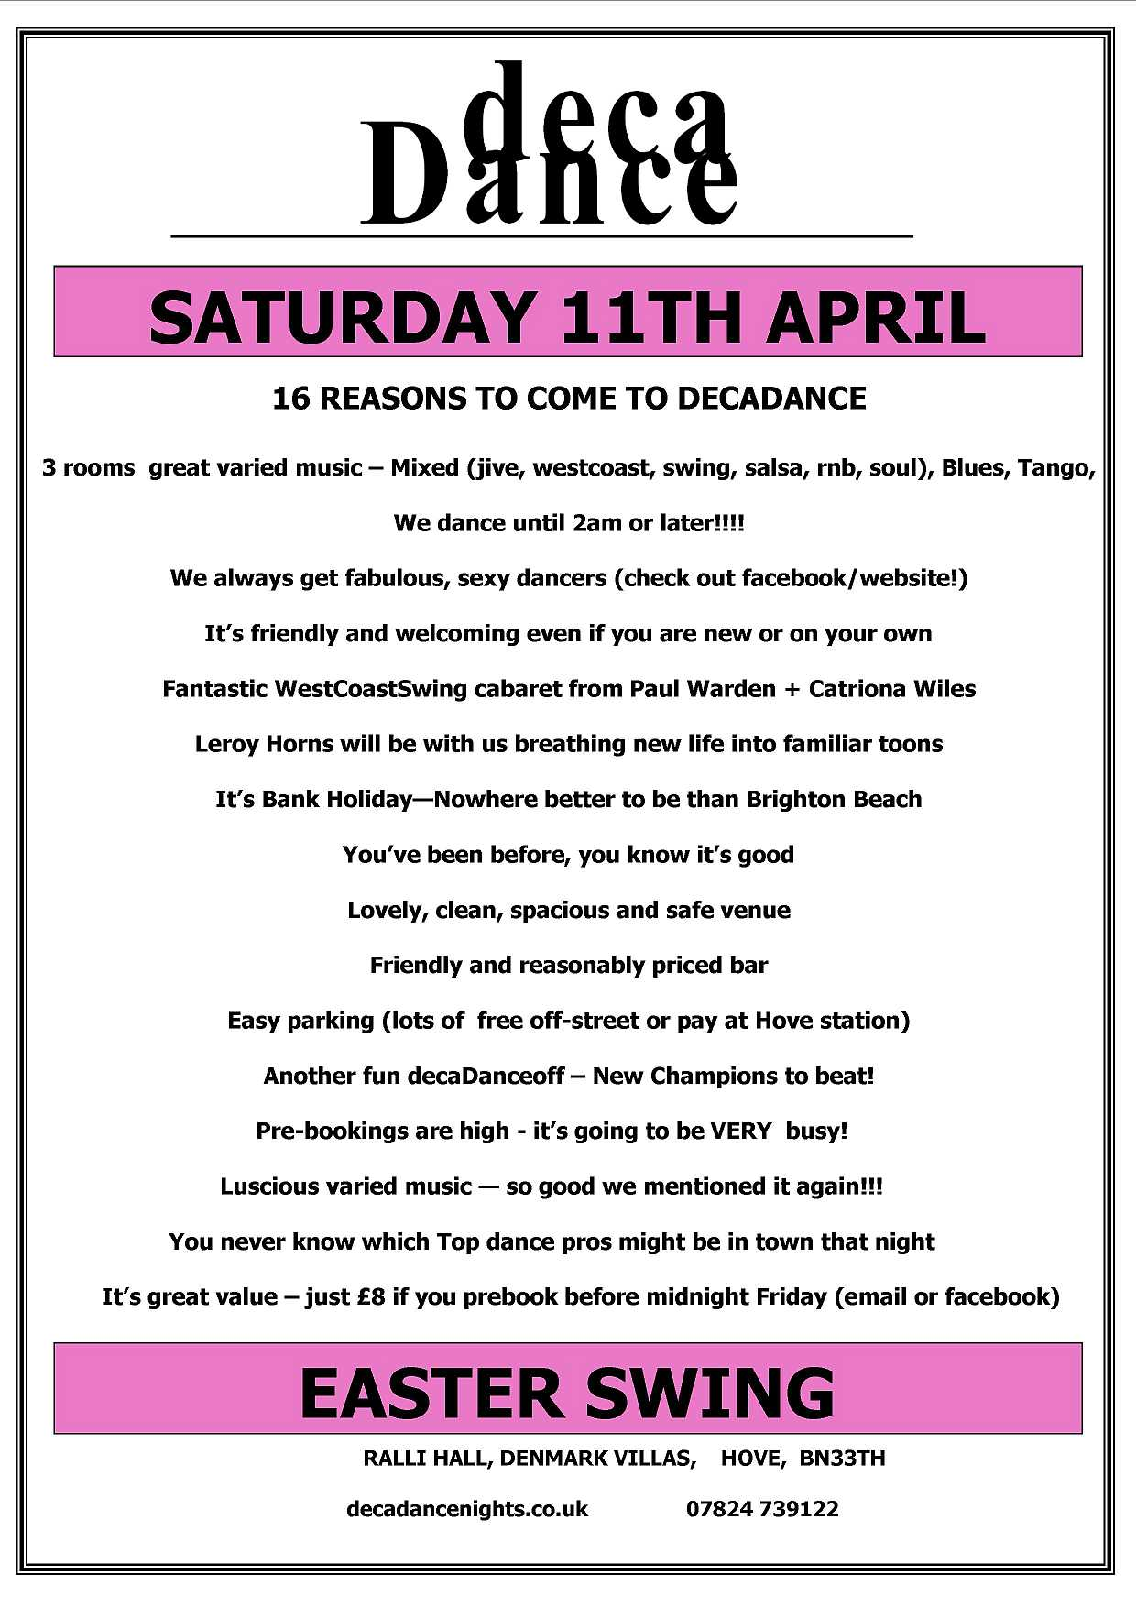

Saturday 11th April - Easter Swing with UK and US Champs Paul Warden and Catriona Wiles
Wow - it will be hard to top last Saturday's decaDance. Fabulous night. Really, really busy and what a vibe. Also big props to David and Marie Claire for giving us such a wonderful and impromptu cabaret.
Moving forwards, it's less than 2 weeks before we do it all again. Can't wait to welcome multiple UK and US champions Paul and Cat to decaDance where they will spellbind you with their cabaret. To prebook and save £2 please email info@decaDancenights.co.uk or sign into the facebook event : http://www.facebook.com/event.php?eid=75458419777
We still have a few spaces left for the workshops during the day. For info on these and the full day package please go to www.westcoastswingbootcamp.co.uk

BluesBootCamp is on May 23d and now open for booking
We are delighted to announce that the first ever BluesBootCamp will be held on May 23rd in Hove.
We adore Blues dancing and so do many of our decaDance regulars. Lots of people have requested we run a bootcamp for blues and we are only to happy to oblige. Our bootcamp will provide a perfect introduction to blues dancing as well as a more technical foundation for those who already enjoy blues dancing. More info is at our (still in development) website www.bluesbootcamp.co.uk
Next decaDance is on Saturday 28th Mar at Ralli Hall!!
Unfortunately the 20th Feb event at The Loft has had to be cancelled. Apologies for any inconvenience but it is outside our control. Due to a run of great dance weekenders and our own bootcamps we have a little time before the next decaDance. However, we sure will make it worth the wait. Great WestCoastSwing demo, hornsman Leroy will be with us once again and we have a great mix of killer tunes for you. 3 rooms of music, great floor, plus the return of the decaDanceoff! We do want to save you money so if you pre-book it's still only £8. We have plenty of decaDances lined up for you after that plus of course we have a whole host of bootcamps coming your way (see diary).
Thanks for the busiest decaDance last saturday!!
We knew from advance bookings it was going to be busy but WOW, that was a BIG night. By 9.30pm the dancefloor was buzzing and it never really let up all night. We weren't far short of 150 people and had some absolutely fabulous dancers in the house. Lots of our top locals + loads from out of town. We are really flattered by just how far people had travelled and also the long awaited visit from our special guests from surrey :)). It was also really nice to see so many new people. Sincere thanks to everyone for coming, dancing so beautifully and continuing to spread the word about decaDance.
Leroy + decadanceoff are back on Saturday!!
Due to popular pressure we've managed to twist Leroy's arm to join us to play another set on Saturday. We really do spoil you! Anyone who hasn't experienced him is in for a real treat. He is a fantastic sax player who adds an extra dimension to the dj'd music in the main room. We also will be running another fun quiz based decaDanceoff with defending champions Paul and Sharon determined to maintain their crown. In celebration of Motown's 50th anniversary the theme will be ....Motown.
WestCoastSwing Bootcamp on April 11th!!
We are delighted to announce that the first ever WestCoastSwing Bootcamp will be held on April 11th Hove. This will be a 6 hour intensive, progressive day for total beginners. The workshops will be taught by the UK and Europe's finest teachers Paul Warden and Catriona Wiles. This is definitely a day not to be missed and is followed by a decaDance in the evening with a full cabaret by Paul and Cat. More news will be posted shortly to our new website www.westcoastswingbootcamp.co.uk . Bookings will be open shortly but as this event is likely to be very popular please pre-register interest by emailing us at info@westcoastswingbootcamp.co.uk .
First decaDance of NEW YEAR is SATURDAY 31st JANUARY
Happy New Year to everyone. Thanks for great support in 2008. This year is going to be even busier with lots of great decaDance and Tangobootcamp events. We kick of at the end of the month with a big 2 room dance at Ralli Hall. All the usual features including of course dancing through until 2am or even later!


